From: https://andrewmtanner.medium.com/how-europe-can-defend-itself-and-ukraine-against-russia-bcd746ca1b0f
Author: Andrew Tanner
Date: Feb 3, 2022
A 13 min read, or you can just click 'Listen' and hear the page !

How Europe Can Defend Itself — And Ukraine — Against Russia
Only a dedicated European Defense Force will ever have the guts or smarts needed to stop Russian aggression.
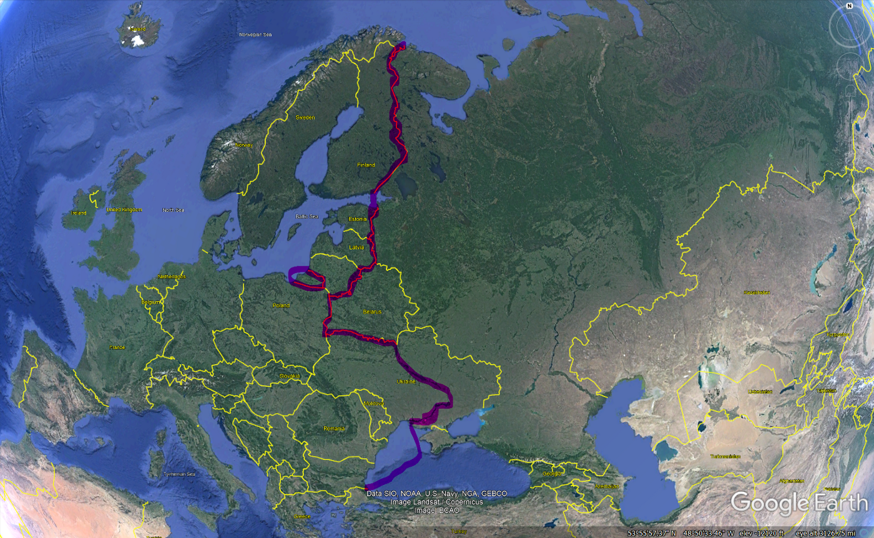
Europe’s New Eastern Front Line. Eastern Ukraine is indefensible, and should be kept free of large military formations.
Europeans, if I had one wish granted by the elder gods today — aside from there not being a war in Ukraine at all — it would be that you all realize America is not your friend.
It never has been. It never will be. In the eyes of America’s elites, Europe is a colony. In the great “superpower” competition American leaders pretend they’re part of, Europe’s role is to be a battleground insulating America from the consequences of its dumb policies. American leaders look down on Europeans, plain and simple.
I am a military veteran. I trained as a cavalry scout in the United States Army back in the day. Mine is a military family, and I hold no illusions about the desirability or benefits of conflict.
The answer is zero. No sane person should ever want a military conflict. Especially not when the participants are armed with nuclear weapons.
Yet sometimes war comes whether you like it or not. And Europe is caught in a tug of war between self-interested American hacks in D.C. and the rising power of Beijing and Moscow.
Simply put, American leaders are so self-absorbed and egotistical they have always seen allies as disposable. The way Ukraine is being abandoned to Putin’s wiles at the same time America is pretending NATO is about to experience a new dawn is a warning for all European countries who have to deal with the Russian bear.
Rarely do I agree with a French President, but Emmanuel Macron is right to want a European-run defense force. When push comes to shove, America will abandon Europe — except Airstip One (England), of course, for reasons of heritage.
The dark secret of NATO is that it its plans to “defend” Germany from the Soviet Union in the Cold War weren’t really military plans at all. Unable to maintain enough military forces in Germany to withstand an all-out Warsaw Pact assault, all NATO planning assumed a war would go nuclear in about a week.
America intended to use nuclear weapons across Eastern Germany and Poland to slow a Soviet rush to the Rhine and threaten to turn the war into an all-out nuclear exchange. This was always a bluff, because no American President would ever sacrifice New York to save Munich, but it was a damned dangerous one for Germans and Poles, whose countries would become radioactive wastelands.
What went down in Afghanistan was pretty much what most long observers of NATO predicted would happen if the alliance ever did go to war. Individual countries would make contributions for political reasons, coordination was never strong, and American generals openly insulted their NATO counterparts.
The dirty little secret of America is that its foreign policy is run by a clique of ideologues who have no scientific understanding of the world. American international relations experts are trained to see America as the leader of the so-called “West” or “Free World” and all allies as subordinate. They’re beholden to a self-serving ideology just like everyone they claim to stand against.
I know, because I earned a degree in political science from UC Berkeley — before enlisting in the Army as a scout. I read their works then saw first-hand how the experts in America have absolutely no clue about basic social science. They’re as ideological as any Soviet commisar. Doing things backwards gave me a unique perspective on how the American foreign policy establishment really works — or doesn’t, as is more often the case.
The fact that the Biden Administration is trumpeting the movement of a few thousand soldiers to Romania, Poland, and Germany when Ukraine faces a Russian force of over 120,000 personnel summarizes American foreign policy perfectly. It’s all about signaling and bluff, directed more at a domestic audience than Russia, which knows well how America operates.
While perpetually wrong foreign policy analysts like Fred Kaplan try to insist Putin is losing, the reality is that America is playing Russia’s tune. Every day the Biden Administration is demonstrating America’s limits. American media hacks trip over themselves trying to time Russia’s invasion based on the weather and Olympics, as if Russia is not prepared to make this crisis last exactly as long as Putin has an opportunity to demonstrate how little America will do to protect its partners.
Americans absolutely love to pretend Putin is some combination of maniac and irredentist imperialist, because it is fundamental to the elite American worldview that they — whoever that happens to be this year — are seen as irrational, emotional actors. Truth is Americans are the ones who have a poor grip on reality — or more accurately, too many experts in soft science fields insist the world works the way they wish, not as it does.
And since there’s nobody to counter them except amateurs and independent analysts, the media doesn’t have to tell the whole story. The tale of Russia making absolutely predictable moves [?The fact is, Russia is making absolutely predictable moves?] because it sees a unique opportunity in the American-led world’s reliance on bluff and fear of hard power.
Putin wants violence to break out in Ukraine before he launches any major operation. All his rhetoric is geared towards that end, presenting what is happening as a NATO attempt to start something with Russia using Ukrainians as meat shields.
This means the likely timetable for a war will be set by small violent actions on the ground in Donbas and possibly in Ukraine as a whole. Putin’s dream is that Ukraine disintegrates so Russian troops can march in to Kyiv to restore order after being invited by a new government. This will prevent the country from fragmenting
But if seizing territory in Eastern Ukraine and destroying most of Ukraine’s military is required first, there’s little reason to believe Putin won’t take that option. Even without a direct, large-scale invasion that would likely trigger immediate international sanctions Russia can probably grind Ukraine’s government down over time.
The key is to just keep the pressure on for as long as it takes. Now that Biden has tried to insulate himself politically by insisting Russia is probably going to attack, Putin has an incentive to draw out the tension. Violence breaking out in Donbas during the Olympics would be portrayed to Russians as a nefarious Ukrainian attempt to escalate, drawing a swift and punishing reaction Russia plays off as self-defense.
Ukraine must be defended, and the European Union must come together to protect its eastern frontier — there is no other option, and relying on America is a fool’s game.
Here’s how to get it done.
First off, every EU member or ally has to be willing to commit 1% of gross domestic product to collective defense. Across the EU, not including allies like Ukraine, this amounts to about $170 billion in annual spending — more than twice Russia’s.
This EU security force should extend its reach right up to Russia’s borders, setting aside concerns about militarizing the situation. Putin has already committed to a militarized Russia-Europe border, so there’s no point in pretending this isn’t the sad but inevitable future until he dies or is overthrown someday.
But this frontier focused defense should not be used to replicate the Cold War style force structures America imposes on NATO!
The European Defense Force must be designed and equipped to be able to degrade and defeat any Russian attack on its own territory, but not project power across Russia’s borders, something Russia’s bloody history means its leaders will always be wary of and use as an excuse for violence.
Practically, you have to fight the bear if it steps onto your lawn. But provoking it in its den is futile and entrenches Putin’s power — something American leaders know well and actively rely on to keep their “allies” buying over-priced American military gear.
To stop an invasion, a good rule of thumb is that you need to deploy at least 1/3 the combat power of the opposing force. This isn’t a straightforward thing to measure, but in general military formations of a similar size and role have around the same amount of combat power, with the battalion tactical groups Russia now uses as a front line element roughly equivalent to a battalion in the American or European model.
Russia can amass and sustain about 120 of these battalions on the front line of Europe, as evidenced by its current deployments in Ukraine. Setting aside the national forces each member country would maintain itself, this means the EU Army has to be able to maintain around 40–50 battalions in the field on a line stretching from the Black Sea to the Baltic, and the Gulf of Riga to the Barents Sea.
EU Army battalions will need to operate in groups of 5, placing
- Scout,
- Guard,
- Heavy,
- Fires, and
- Engineer battalions
under the overall command of a Headquarters unit that manages operations and logistics. Each battalion has to be a self-contained combat unit capable of fighting ground and air units while maintaining supply and communications connections to the rest of the force under difficult conditions.
Scout battalions are equipped with wheeled vehicles, advanced sensors, and as many remote weapons systems as they can manage. In modern war, what is seen is swiftly targeted and killed, so the basic combat rhythm involves detecting a target, shooting at it, then running away before its buddies can plaster you in return.
Remotely controlled machine guns and anti-tank missiles allow a light border force to impede an enemy’s movement without exposing itself to heavy attack. All along the border with Russia, EU countries need to have a permanent screening force of scout battalions ready to repel a sudden assault while minimizing their losses. Basically, they ambush and retreat, ambush and retreat, slowing the enemy down and disorganizing their formations without exposing themselves more thean needed.
Guard battalions are infantry-heavy formations with enough firepower to hold a line. Their role in a Russian attack is to dig in around vital points on the landscape like defensible terrain along invasion routes and urban areas. After struggling for several days to make progress against hidden traps and hit and run attacks, the attacking force’s firepower will be depleted and its leading elements vulnerable to a large-scale ambush.
All battalions will be trained to fight independently or go into cover if outgunned, using secure communications to coordinate actions even if separated from other forces — as they must expect to be. Once a Russian attack’s momentum is partially spent and casualties have been inflicted, small-scale counter-attacks by Guard and Scout units working together can restore a front and trap hostile Russian units that have pushed too far forward.
Heavy battalions will be filled with tanks, infantry fighting vehicles, and other expensive, top-line war gear and sent into any fight as soon as Russian forces are vulnerable to a counterpunch or if there is a need to block a successful Russian push through the first lines of defense. As these are the kinds of units that could actually threaten an invasion of Russian territory, they will be held back from the front lines as reserves.
Fires battalions are to be equipped with long-range rocket artillery and precision guided missiles as well as armed reconnaissance drones. Their role is to sit well back from the battlefield and direct massive bombardments from well out of range of Russian counterattacks. From minute one of an invasion they can supplement the first lines of defense, supporting the Scouts and their ambush tactics.
Engineer battalions are defensive formations that focus on battlefield shaping — developing and maintaining the communications and signals equipment and connections needed to coordinate the defense as well as traditional construction of fortifications. Deployed in smaller task groups as needed in a defensive area, their job is to remain hidden combat enablers and force multipliers — they handle network security as well, keeping everyone connected despite Russian electronic warfare and hacking.
A total of nine of brigades with one of each battalion need to be maintained on active duty at any given time, with nine more held in reserve further west. Each participating nation will retain its own national guard that can supplement this force on its soil, but it won’t be relied on in major combat.
To counter Russia’s powerful air force and tactical missile arsenal, each of the frontline brigades has to be partnered with an integrated air defense brigade that unites anti-missile and anti-aircraft capabilities to produce a no-fly zone at least two hundred kilometers in diameter. THAAD, Patriot, and NASAMS based defenses will be needed to shoot down incoming tactical missiles, drones, and combat aircraft. Iron Dome style anti-rocket defenses are also vital.
Further, each of these air defense brigades has to be supported by a combat air wing comprised of a squadron of fixed wing Typhoon, Rafale, and Gripen fighters plus a high-endurance drones squadron, an aerial support squadron, transport aircraft, and helicopters. Together with the air defense brigades, these nine air wings will place nearly two hundred combat aircraft near enough to the Russian border to stop air attacks. As with the ground brigades, nine reserve wings will be maintained to bolster defenses and replace losses in an open war.
Air defenses will not include long-range strike aircraft or other clearly offensive weapons like stealthy cruise missiles. These pose too much of a threat to Russia and will draw heavy attacks in a real conflict — the goal is to maintain a defended bubble behind the lines safe from air assault where forces can organize the ground defense and use artillery and drone strikes to support ground forces.
The Land and Air Branches of the EU Defense Forces will have the primary responsibility for handling Russian aggression, but the Sea branch will play a role in securing access to the Baltic states and preventing Russian Naval forces from attempting any kind of oceanic blockade. Three aircraft carrier battle groups developed as improvements on the French Charles de Gaulle design will form the deployable core of the European fleet, each with half a dozen large escorts and amphibious warfare capabilities.
That keeps the Norwegian, Baltic, and Black Sea coasts protected and Russian naval forces bottled up. Europe in a major conflict cannot be separated from the rest of the world, and escorting merchant convoys might be necessary in the future.
Military spending is a tragic waste, especially when the world has to get on with dealing with the worsening climate crisis, yet worse is the existence of a bully who uses their own military force to redraw borders and pick fights with neighbors. Europe today is trapped between Russia and America, both ruled by leaders who need a new Cold War with someone to justify the amount of money spent on their military forces.
It is vital for America’s allies to realized that Trump was not a blip in American history — he is the culmination of two centuries of nativism and a sign of America’s exceptionalism mutating into a virulent cancer. Americans today don’t realize that the country only belatedly got involved in the Second World War to stop Hitler, which makes it so bitterly ironic that American leaders all push the stale old myth that America saved Europe.
America split Europe in half, surrendering the eastern half to the Soviet Union, essentially making good on the Nazi-era Molotov-Ribbentrop Pact that gave Stalin free reign in the Baltics and much of modern-day Poland in 1939. For half a century America let the Soviet Union do whatever it wanted to in Hungary and Czechoslovakia and Finland while turning around and proclaiming itself the global bulwark against communism.
This convenient fiction might have been useful when Soviet tanks were parked in the middle of Germany, but since the 1990s all it has done is provoke a Russian counterattack headed by Putin and backed by ordinary Russians who feel slighted by a “West” that casts Russians as an other, not truly European and so acceptable to demonize and stereotype. Anyone who truly believes America will risk a nuclear conflict over the Baltic states, Finland, or even Poland needs their head examined — America’s enemies serve a purpose for America’s wealthy leading elite and no one else.
The time for Europe to stand up and defend Ukraine is now. This does not mean accepting the Kyiv government’s stupid obsession with pretending Ukraine’s 2014 borders will be restores Crimea is lost, Donbas is lost, and the Azov coast might soon be lost too, depending on how swiftly Ukraine is broken by Russia’s unrelenting aggression.
Without real military aid, not a few hundred tons of small arms and promises of sanctions, all Ukraine will eventually be lost. This is Putin’s dream, and he clearly intends to pressure Ukraine until internal violence breaks out, giving him an excuse to directly intervene.
Putin is in a position to simply ratchet up pressure until Ukraine cracks. All he needs is some sort of violence against Russians to be able to claim he was right in warning Ukraine is plotting to retake its lost lands, and as justified as that might be, Ukraine’s leaders have to understand it isn’t happening anytime soon.
Ukraine’s choice [fate?] now is accepting the loss of territories it can’t defend and walking into a Russian trap. NATO will never let Ukraine join so long as the conflict in the east is unsettled.
Only if Russia itself disintegrates after Putin is gone will the ever-shifting borders of Russia change. For all his talk of Russia and Ukraine sharing a common heritage and origin, Putin clearly knows full well Russia itself is a fairly new country, prone to fragmenting into city-states — as it usually was in medieval times.
To defend Ukraine and itself, Europe needs its own defense force entirely independent from the United States. But to stabilize the situation in Ukraine, Kyiv has to accept the loss of these eastern territories and work to defend what of its territory it still can.
The time has come to crop the NATO charade. Russia has to be prevented from thinking it can redraw the map of Europe and the EU can’t be trapped in the sick Moscow-Washington codependency any longer.
If the European Union, one of recent history’s most ambitious and justified national projects, stands any chance of surviving, NATO must die. The EU Defense Force must rise and take a stand against Russia.
America, simply put, is a bad bet for Europeans. The country is likely to disintegrate in the near future. Americans don’t truly care about the rest of the world and can’t understand it because the education system here is so utterly broken. America’s leaders are determined to make other peoples suffer for their chronic strategic ineptitude.
It’s time, Europe. The postwar era is dead and done.
Europeans now stand together, or they will surely hang separately.
Caught between Eagle and Bear, there are no other options.
332
8

